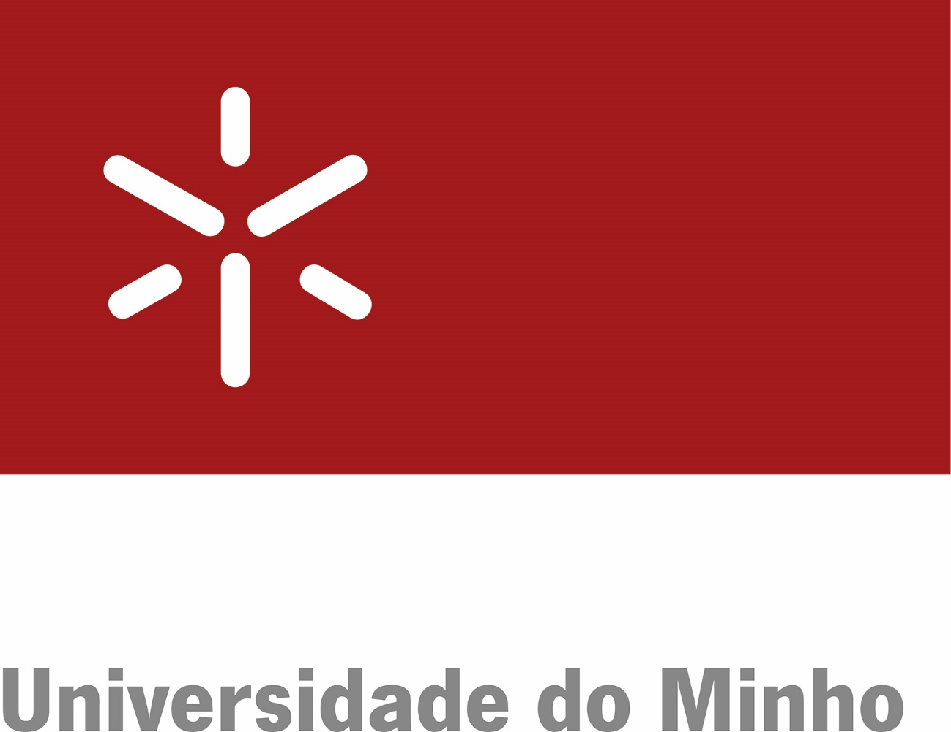 | [logo from the partner university]

MEMORANDUM OF UNDERSTANDING
BETWEEN
THE UNIVERSITY OF MINHO, PORTUGAL
AND
THE UNIVERSITY [name of the partner university], [country of the partner university]

The University of Minho, hereinafter referred to as UMinho, a public higher education institution of foundational nature, under Law 62/2007, of September 10th, located at Largo do Paço, 4704-553 Braga, Portugal, VAT 502 011 378, herein represented by its Rector, Professor Rui Vieira de Castro,
and
The University of [name of the partner university], hereinafter referred to as [diminutive/acronym of the partner university], located at [address of the partner university], herein represented by its Rector, Professor [name of the Rector of the partner university],
hereinafter jointly referred to as Parties.

Recognizing the importance of promoting collaboration in areas of mutual interest, and in the spirit of contributing for the development of programmes of academic, scientific and technical cooperation, decide to establish this Memorandum of Understanding (MoU), which shall be governed by the following clauses:

First Clause
Scope
In accordance to the legislation of each country and the applicable regulations, the Parties aim at developing and cooperating in activities concerning:
- Exchange of students,
- Exchange of faculty and researchers,
- Exchange of technical, administrative and management staff,
- Teaching and education projects,
- Joint research and publications in scientific journals,
- Extension or interaction with the society projects,
- Joint organisation of conferences, workshops, and/or other scientific events,
- Any other type of collaboration which may be considered opportune and of mutual interest.

Second Clause
Addenda
1. The details and specifications for each of the aforementioned collaborations in the First Clause will be defined through the establishment of Addenda to this MoU, to be proposed by either Party.
2. The Addenda shall specify the scope, the schedule of activities and the financial framework for the specific cooperation activities to be carried out, as well as any other details agreed by the Parties.

Third Clause
Institutional Coordinators
For each Addendum, the Parties will appoint a contact person who will act as institutional coordinator of the cooperation activities to be developed.

Fourth Clause
Confidentiality
The Parties commit to ensure secrecy and confidentiality regarding all the information to which they may have access under this MoU, and will commit not to use such information for any purposes other than those set forth in this MoU, except with the prior written consent of the other Party, to be obtained, on a case-by-case basis, and in writing.

Fifth Clause
Intellectual Property
1. Within the scope of this MoU, no license or exploitation right shall be granted by the holder to the other Party concerning intellectual property rights, whether copyright or industrial property rights, or concerning the knowledge owned.
2. Any activities that may be developed between the Parties under this MoU shall be subject to a written Addendum regulating, furthermore, the issue of intellectual property rights over results and their exploitation, as well as provisions regarding confidentiality and the publication of results.

Sixth Clause
Validity
This MoU shall enter into force on the date of signature and shall be valid for a period of 5 (five) years, and may be renewed for an equal period whenever the Parties express an interest in it.

Seventh Clause
Termination
1. Each Party may withdraw from this MoU at any time by giving written notice within 180 (one hundred and eighty) calendar days before its expiration, to be sent by registered mail.
2. Such notice will not affect commitments already made as of the date of the communication.

Eighth Clause
Doubts and Omissions
To clarify any doubts that may rise in the implementation and interpretation of this MoU, the Parties shall use their best endeavours to reach a consensual solution. If this is not possible, the Parties shall appoint, by mutual agreement, a third physical person to act as mediator by mutual agreement.

Having read and approved, this MoU is signed by the legal representatives of each institution, in 2 (two) copies, in English, of equal content and form.

Braga, __________________________ |  | [City of the partner university], ________
On behalf of the University of Minho,  _____________________________  Professor Rui Vieira de Castro  Rector |  | On behalf of the University [name of the partner university],  _____________________________  Professor [name of the Rector of the partner university]  Rector

